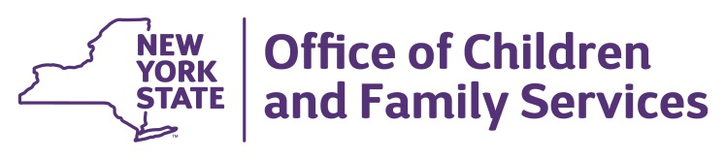
Andrew m. cuomo  Governor | SHEILA J. POOLE  Commissioner

June 28, 2021

Dear Provider,
This letter is to inform you that effective immediately there are important changes to the COVID-19 related requirements for child care programs. Please read this information carefully. If you have any questions, please reach out to your regulator.
The June 7, 2021 “Interim Guidance for Child Care, Day Camp, and Overnight Camp Programs During the COVID-19 Public Health Emergency” issued by the New York State Department of Health is no longer in effect. This guidance included interim requirements to reduce the spread of COVID-19 such as enhanced sign-in procedures and temperature screenings.
Please note, the CDC still strongly recommends unvaccinated persons to continue to wear masks indoors. Similarly, masks remain strongly recommended for children in child care settings and camps when indoors. This is consistent with guidance from the Center for Disease Control and Prevention (CDC). More detailed information on CDC guidance can be found at: https://www.cdc.gov/
Child care programs are free to continue to adhere to the archived NYSDOH Interim Guidance for Child Care and Summer Camps (June 7, 2021 https://forward.ny.gov/archived-industry-guidance), or implement other health precautions for their staff and children such as requiring masks, cohorting, and/or six feet of social distancing, however, they are not required to.
Child care programs are required to remain in compliance with New York State Child Day Care Regulations at all times. The regulations are posted in English and Spanish at: https://ocfs.ny.gov/programs/childcare/regulations/.
Thank you for your tireless efforts and flexibility throughout the pandemic. Your commitment to the health and well-being of our children is deeply appreciated.
Sincerely,
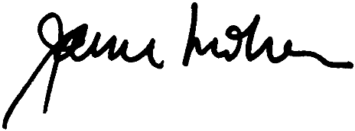
Janice Molnar, Ph.D.
Deputy Commissioner
Division of Child Care Services

